**Week 16:** *Matthew 14*

**Hook** 

**Main Point: Jesus is King of the universe – the wind and waves obey Him.**

Have you felt a bit powerless lately? Many found themselves feeling this way during the shelter-in-place portion of the coronavirus pandemic. Break your LifeGroup into small groups and discuss what “super power” you would have wished for while you sheltered in place. Reconvene the groups and ask for each of the small groups to share an answer or two.

**Q: Share some other times in your life during which you felt powerless. What helped you to navigate those days?**

**Q: How does the Lord use your “powerless” seasons for your good and His glory?**

**Transition:** Today Jesus will demonstrate that He is King of the universe — more powerful than the fiercest elements.

**Week 16:** *Matthew 14*

**Book**

**Main Point: Jesus is King of the universe – the wind and waves obey Him.**

**Matthew 14:1–12 [Read]**

**Talking Point 1:** The death of John the Baptist foreshadowed the death of Jesus.

**Q: Why did Herod feel so conflicted about John the Baptist?**

**Q: Why did he have John beheaded even though he was sorry about it?**

John the Baptist had been in prison for nearly two years, beginning just after the first Passover of Jesus’ ministry and ending a year before Jesus died. According to first-century Jewish historian Josephus, John was held in a dungeon at Herod Antipas’s fortress, Machaerus, in Perea.[1] John was imprisoned by Herod Antipas because he had spoken out against Herod’s relationship with Herodias, his brother Philip’s wife. Their culture did not have laws protecting freedom of speech, so publicly denouncing a king’s character would have been suicide for Romans. Israel’s tradition protected prophets from being punished for speaking against rulers, but the most vicious ones, like Herod, ignored it and followed Roman culture.[2]

Though Herod had had John arrested, he felt conflicted about putting him to death. Josephus argued that Herod’s imprisonment of John was less about morality than about politics. John had a lot of influence with the people, and he saw John as a political threat. John’s public outcry against him might turn the people against him. His reign was already unstable — his first wife’s father, Nabetean king Aretas, attacked him after Herod divorced her for Herodias, and the attack led to his public humiliation. When Aretas finally defeated him a few years later, many of the people believed it was divine judgment for his execution of John.[3]

Herod’s initial actions of committing adultery with his brother’s wife were against Jewish law on two levels, both adultery in general (Exodus 20:14) and sleeping with his brother’s wife specifically (Leviticus 18:16). Even if the people had been understanding about that, they would have been disgusted by Herod’s lustful desire toward Herodias’s daughter who danced for him at the feast. The fact that he was sleeping with her mother made his behavior toward her incestuous (Leviticus 18:17), even if he weren’t yet married to her mother. Also, since Herodias was his brother’s wife, that made her daughter his niece! In addition, it was demeaning to even ask her to dance. She was a member of the royal family. Performing in this way was something slaves or servants or concubines did. It was so unusual that theologian and scholar Hugh Anderson says it could have only been done in a drunken stupor.[4]

So Herod, in a lustful, drunken stupor, made an oath he would later regret. Jewish religious leaders allowed for breaking an oath if keeping it led to more evil, but because he had made the oath in front of all of his dinner guests, Herod felt he had to keep it to maintain his honor. Jewish law forbade execution without a trial and outlawed beheading. However, it was the least painful Roman method of execution.[5] But the presenting of John’s head on a platter was over the top, even for Romans. It was not completely unheard of, but certainly not common and would have been considered gruesome and extremely disrespectful, especially for a well-respected prophet.[6]

John’s disciples risked their own lives to come and bury his body, but they would have considered it their final act of loyalty to their master. Then they went to tell Jesus, which scholars believe means they began to follow Jesus as some of His disciples, part of the wider group beyond the Twelve.[7] John was executed about a year before Jesus was and foreshadowed what would happen to Him and eventually to His followers as well.

**Q: How do you think John’s death would have made Jesus feel?**

**Q: How do all these stories and passages in the Bible about Jesus’ followers being martyred for their faith make you feel?**

**Q: Why did John feel the need to publicly rebuke Herod Antipas for his sins? Do we have the same responsibility today? Why or why not?**

**Matthew 14:13–21 [Read]**

**Talking Point 2:** Jesus fed the 5,000 just as God had fed Israel in the wilderness.

**Q: Why did Jesus withdraw from the crowds to a desolate place by Himself?**

**Q: In what ways does this connect to the Old Testament miracle of the manna in the wilderness?**

Matthew’s version of the feeding of the 5,000 is shorter than those of the other Gospels. We don’t meet the young boy who offers the loaves and fish or hear Philip’s question about buying bread for the people, as in John 6. In Matthew, this miracle happens right after Jesus has heard about John’s death and withdrawn to a solitary place to grieve and pray. This story and the next, of Jesus’ walking on the water, both point to Christ’s divinity. This miracle is a reflection of God’s feeding His people manna in the wilderness, and His calming the storm (Mark 6:51) shows that He had the ultimate authority of God over the wind and the waves.

When Jesus saw the crowd, He had compassion on them, just as the Lord had compassion on His people (Exodus 34:6; Psalm 103:8; 145:8). Jesus’ caring provision for the crowd of everyday people stands in stark contrast to Herod Antipas’s drunken feast with the aristocracy. This was a completely different kind of king. While Herod Antipas was like the evil shepherds of Israel who were condemned in Ezekiel 34, Jesus is the good shepherd of Psalm 23. This miracle reveals not only the power of Jesus, but His heart for His people.

Jesus’ feeding of the 5,000 in a “desolate place” is a clear allusion to God’s provision of manna for Israel in the wilderness. It also resembles a miracle performed by Elisha, but even greater. In 2 Kings 4:42–44, Elisha’s servant asked how he could set only 20 loves of barley bread before a hundred men, but God multiplied it, with some left over. Jesus’ miracle was even greater – only five loaves of bread for 5,000 men with an abundant amount left over.[8]

There really was no option other than a miracle. Even if they had gone into town to buy bread, the small towns of the area (only 3,000 people at the largest) probably wouldn’t have enough extra bread to buy, even if the disciples could afford it. In John’s version, Philip says it would take more than six months’ wages to buy enough bread for each person to have only one bite (John 6:7). By evening, most of the day’s bread would have been eaten already and, at this point in the year (the spring) the previous year’s grain stores would be running low, so they may not have enough extra to sell anyway.[9] One may wonder why these thousands of people followed Jesus into this desolate place without bringing food with them, but Jesus didn’t blame them or make them fend for themselves. He provided.

As God had done with His people so many times in the Old Testament, Jesus took what His disciples had and multiplied it. When Moses asked God for a sign to take to Pharaoh, God used the shepherd’s rod that was already in his hand to do miracles. When a widow needed help, Elijah asked what she already had in her house and he multiplied it. That Jesus used the disciples to distribute the food and then collect the leftovers was indicative of their role in His mission. Jesus said, “*You* give them something to eat” (v. 16), and there were 12 baskets left over. Jesus could have simply had manna rain down from heaven or food appear at each person’s feet. Instead, He used the disciples and the resources they had to serve the people. In the same way, Jesus desires to use us and our gifts and resources to build His kingdom and accomplish His mission. It doesn’t matter how little we think we have to offer. Combined with the power of the Holy Spirit, Jesus can use it and multiply it to do great things.

The leftovers of the meal showed God’s lavish abundance in provision for His people. In ancient Jewish culture, the wealthy were expected to provide enough food at their feasts that there would be leftovers.[10] Here, everyone ate until they were stuffed full, and they still had 12 basketsful left over – one for each disciple, representative of all 12 tribes of Israel. This was an extravagant miracle – 5,000 men plus women and children, more than 50 times what Elisha had done. God is able to do abundantly more than we could ever ask or imagine (Ephesians 3:20). He wants to give good gifts to those who ask Him, like a loving Father (Matthew 7:7–11). Nothing is too difficult for God (Jeremiah 32:27), every good and perfect gift comes from Him (James 1:17). God’s people do not need to worry about anything. He will provide all they need (Matthew 6), but not necessarily everything they think they want. Not because He doesn’t want to give us what we want, but because sometimes our desires aren’t what is best for us. God wants to give us what is best, what is in line with His will for our lives. Saying God wants to give us what we *need* doesn’t mean He will only give us the bare necessities, but that He will give us what is *best* for us and abundantly more than we can even imagine.

**Q: In what ways has God supernaturally provided for you in the past?**

**Q: In what ways has God given you what you really needed, and it turned out to be even better than what you thought you wanted and what you had asked for?**

**Q: Keeping in mind that God wants to give us abundantly more than we can imagine but only what is truly best for us, how should we pray for God’s provision in our lives?**

**Matthew 14:22–36 [Read]**

**Talking Point 3:** Calming the sea proved that Jesus really was God. Only God could do that.

**Q: Why did Peter start to sink? Why was his reaction to sinking the right thing to do?**

**Q: Why did the disciples worship Jesus after this miracle?**

The Sea of Galilee has an unusual climate, and storms can arise quickly and ferociously. Set in the hills of northern Israel, the Sea of Galilee is nearly 700 feet below sea level. On the east side, a continuous wall of steep hills rises to the height of 1,900 feet above the lake. Winds funnel through the east-west aligned Galilee hill country and stir up the waters quickly. A peaceful calm can quickly be transformed by a violent storm. A storm in March 1992 sent 10-foot waves crashing into downtown Tiberias.[11]

These fierce storms scared ancient people and caused them to avoid large bodies of water. Pagan stories depicted the sea as a monstrous beast and a place where Baal battled other gods. In Jesus’ day, Jewish people feared the sea, calling it an abyss and using it as a symbol of chaos and hell. For Jesus to be able to command the sea and to walk calmly on the water while the sea raged around Him was a clear sign of His divinity. In Jewish tradition, only God could tame the winds and sea (Job 9:8; Psalm 107:29). It was understandable that the disciples were shocked at Jesus’ ability to walk on water and wondered at this divine power.[12]

Our passage says the boat was being “beaten by the waves, for the wind was against them” (v. 24). We need to realize that Jesus wasn’t walking on water that was as clear as glass. It wasn’t possible that he was just walking on a sand bar, as critics of the supernatural elements of the Bible claim. He was walking on the water *through a raging storm*. We typically think about Jesus’ walking on the water looking like picture #1, but it was really more like #2:

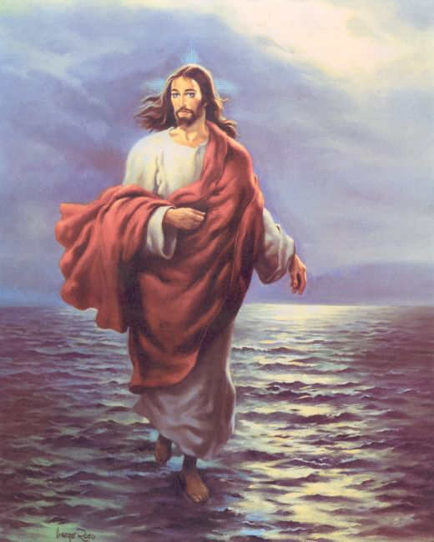 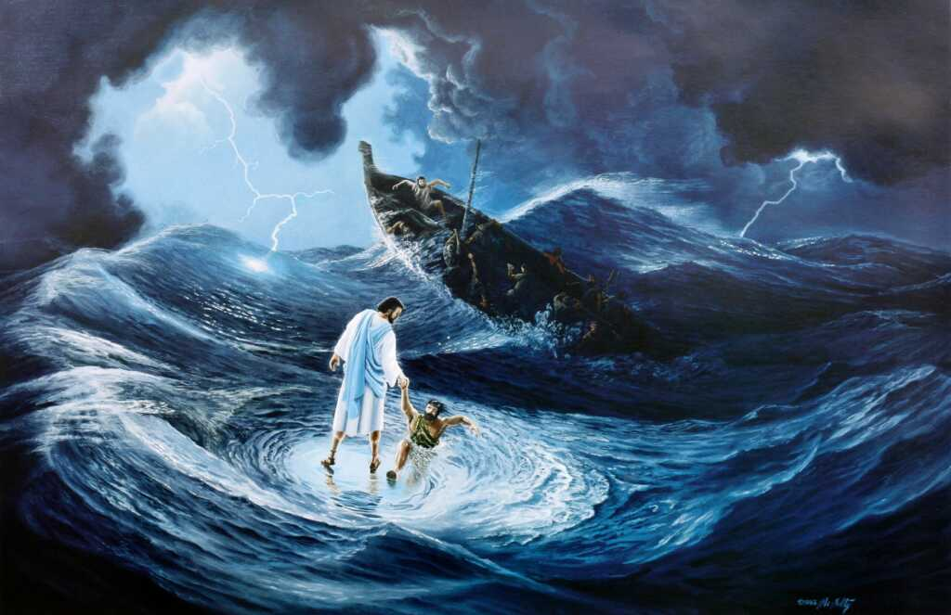[13]

1. 2.

They were terrified for a reason! Also, by the fourth watch of the night (between 3:00 and 6:00 a.m.), they had been struggling against these waves for a long time and were exhausted. When the disciples saw Him walking on the sea, they didn’t recognize Him because they simply could not have imagined any human being walking on water like that. Also, they had left Jesus alone on the mountain to pray (v. 23), and the boat was a long way from the land (v. 24). Even if they had all the faith in the world, it wouldn’t have occurred to them that Jesus would have a) known what was going on with them or b) been able to catch up to them in a storm, even in a boat, much less walking on water.

It would have been completely normal for them to think this had to be some supernatural creature. It was – but not a ghost. It was God Himself. When they cried out in fear, Jesus answered, “It is I!” which literally means “I AM,” God’s personal name in the Old Testament (Exodus 3:6). Jesus showed them He was God by doing what God alone can do and declaring He was “I AM.”[14] Once they saw it was Jesus, they were no longer afraid. They had seen Jesus calm the sea before (Matthew 8:23–27). New Testament scholar Craig S. Keener writes, “They knew Him enough to know that if he was there, he would bring them through their storm.”[15]

Peter didn’t step out of the boat onto normal water. He stepped out of the boat onto *a raging sea,* onto huge waves in the middle of fierce winds and pouring rain. On purpose. We may criticize Peter for his lack of faith, but it took incredible faith for him to step out of the boat at all! Jesus didn’t chastise Peter for his lack of faith. He wasn’t mad at him. He didn’t say Peter shouldn’t have doubted or that his doubt wasn’t normal. He just said, “You don’t have to worry like normal people do. Because you have Me.”

Peter had great faith to step out of the boat, but when he saw the wind, he became frightened (v. 30). He only became afraid because he took his eyes off Jesus. When we take our eyes off Jesus and put them on our circumstances, that is when we become afraid. But if we can keep our eyes on Jesus, we can walk on water with Him. When Peter started to sink, he cried out to Jesus (v. 30) and *immediately* Jesus grabbed him (v. 31). When the waves got scary, Peter went to the right person. He didn’t try to do it on his own. He didn’t *completely* doubt Jesus and holler for the guys in the boat to come get him. He called out to Jesus. It’s impossible for us to never be afraid, but what do we do when we are afraid? To whom do we cry out?

Jesus used the phrase, “you of little faith,” four times – both times when He calmed the sea and twice when He talked about not worrying about food or clothes (6:30–33; 16:5–12). Provision and safety – two of the things about which we should have faith, but often worry about. When He used this phrase in the Sermon on the Mount, Jesus said the Gentiles worried about these things, but His disciples didn’t have to worry. It’s normal for people to worry about these things, but they didn’t have to be “normal.” They could be free from worry and fear.

When He used the phrase in Matthew 16, the disciples were worried about having enough bread, but Jesus wanted to talk to them about deeper things. He wants to give us so much more than we can imagine spiritually, but we are consumed with worry over food and drink and the day-to-day concerns of this life. Jesus is saying, “Let go of all of that worry and follow Me. Even if following Me looks like stepping out of a boat into a raging storm, you don’t have to worry, because I will be with you.” Faith isn’t just about believing in Jesus; it’s about *following* Him. Our faith doesn’t always keep us safe. Sometimes, as when missionaries are called into dangerous areas, following Jesus means going *into* the storm. Stepping out in faith may seem like a risk to “normal” people, but there is no better place to be than in God’s will, even if it isn’t physically safe. If we keep our eyes on Jesus, no matter how high the waves rage around us, we can walk on water in the midst of them. Following Jesus isn’t always comfortable. It may even be downright dangerous. But it’s the only way you’re ever going to walk on water.

This story ends in worship because it is the only response the disciples could possibly have to this situation. Jesus just told them and showed them that He was God. They stood face-to-face with the God of the universe. No matter what doubts or fears they may have felt earlier, in that moment, all they could do was worship Him and declare that He was the Son of God.

**Q: In what ways do you struggle with trusting Jesus and following Him?**

**Q: How is Jesus asking you to step out of your comfort zone in faith?**

**Q: How is following Jesus connected to worship (see Romans 12:1–2)?**

**Week 16:** *Matthew 14*

**Took**

**Main Point: Jesus is King of the universe – the wind and waves obey Him.**

Have you ever noticed “blinders” on a horse? These are tools that cover a portion of the horses’ vision so that it will not be distracted by random things happening in its peripheral vision. Blinders help the horse to focus on what’s ahead instead of becoming sidetracked or spooked by what’s behind or beside. Have you allowed circumstances to distract you? Like Peter, have the pressing matters of today swayed your eyes from Jesus? Ask for the Lord’s help in refusing to fall victim to the challenges that vie for your attention. Focus on Jesus and watch as He performs wonder after wonder in your life.

**CHALLENGES**

**THINK:** How has Jesus shown you that you can follow Him in trust? How has He proven Himself to be faithful to you? How has He provided for you? How have you seen that following His will was best, even if it were scary or hard or uncomfortable?

**PRAY:** For Jesus to show you what His will is, how He wants to use you to build His kingdom, and how He wants you to step out in faith to follow Him. Pray for the faith to follow Him, no matter where He calls you to go.

**ACT:** Take a risk for the Gospel. Thinking of your own gifts – what you already have – and how God can multiply them with the power of His Holy Spirit, consider one way you can step out of your comfort zone this week to share the Gospel with someone through word or deed.

Editing by Hayden Seeley

1. Nelson Glueck, *Rivers in the Desert: A History of the Negev* (New York, NY: Grove Press, 1960).
2. F. F. Bruce, *New Testament History* (Garden City, NJ: Doubleday and Company, 1972).
3. Josephus, *Antiquities of the Jews*, Book 18, Chapter 5.
4. Hugh Anderson, *The Gospel of Mark, New Century Bible* (London, UK: Oliphants, 1976).
5. Robert H. Gundry, *Matthew: A Commentary on His Literary and Theological Art* (Grand Rapids, MI: Eerdmans,1982).
6. D. A. Carson, Matthew, *The Expositor’s Bible Commentary* (Grand Rapids, MI: Zondervan, 1984).
7. Craig S. Keener, *A Commentary on the Gospel of Matthew* (Grand Rapids, MI: Eerdmans, 1999).
8. Dale C. Allison, Jr., *The New Moses: A Matthean Typology* (Minneapolis, MN: Fortress Press, 1993).
9. William L. Lane, *The Gospel According to Mark, New International Commentary on the New Testament* (Grand Rapids, MI: Eerdmans, 1974).
10. Gerd Theissen, *The Miracle Stories of the Early Christian Tradition* (Philadelphia, PA: Fortress Press, 1983).
11. <http://www.bibleplaces.com/seagalilee.htm>
12. Craig S. Keener, *The IVP Bible Background Commentary: New Testament* (Downers Grove, IL: InterVarsity Press, 1993), 211.
13. Norbert McNulty, “Jesus Walking on the Water” - <http://www.lordsart.com/jewaonwabiar.html>
14. W. D. Davies and Dale C. Allison, Jr., *A Critical and Exegetical Commentary on the Gospel According to St. Matthew* (Edinburgh: T & T Clark, 1991).
15. Craig S. Keener, *A Commentary on the Gospel of Matthew* (Grand Rapids, MI: Eerdmans, 1999).